**Assignment 1 Date: 30.06.2025.**

1. Traditional code with ML code to **eligible to vote or not (Use case) – Logistic regression**
2. Discount on purchases **Use case Logistic regression**
3. Disease detection **Use case Logistic regression**
4. **Data frame preparations – Customer account to get loan approval write or not**
5. **Data cleaning operations**
6. **Data collection – downloaded the iris and other data sets and printing**
7. **Linear regression – Calculation of hours studies(use case)**
8. **Plotting the graph**
9. **Sentiment analysis – spam or not , customer reviews (Use cases)**
10. Product categorization
11. **Evaluation for the models**
12. **Working with pandas, matplotlib, sklearn**
13. **Preprocessing of text data for NLP applications**
14. **Name few classification and regression use cases and develop a model of Logistic regression to work on use case**

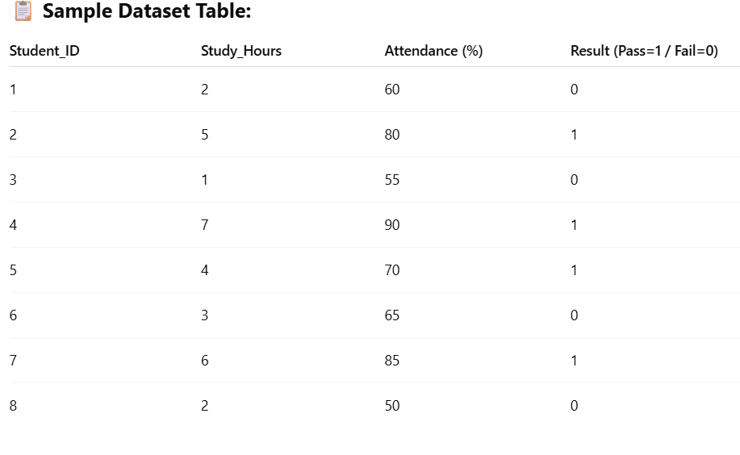

1. **Perform the data cleaning operations on the following data frames**

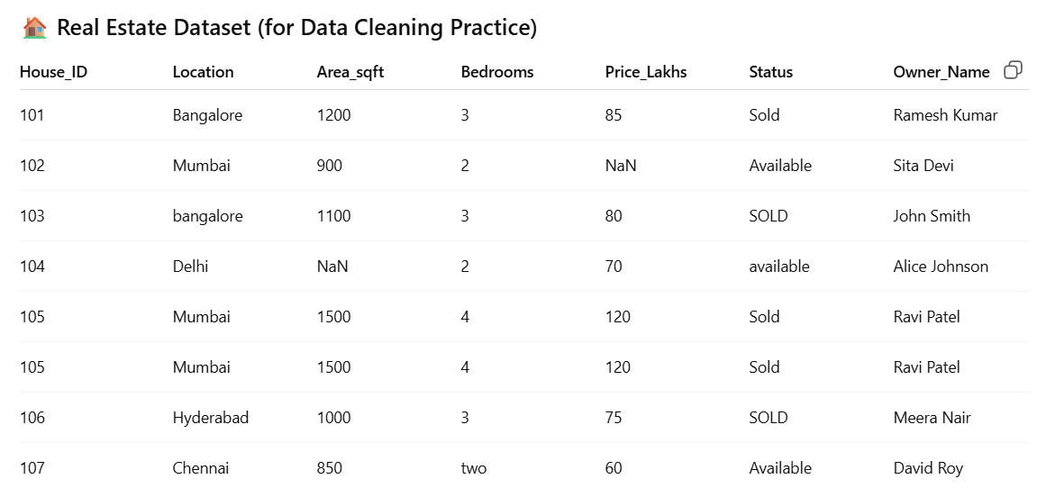

**3. Perform some text cleaning operation on the following text**

| **ID** | **Raw_Text** |
| --- | --- |
| 1 | "Hello!!! This is a SAMPLE text 😊 with UPPERCASE letters & symbols!!!" |
| 2 | " Visit us at: <https://example.com> for more info... " |
| 3 | "I can't believe it's already 2025!! Time flies 123..." |
| 4 | "Data Cleaning -- it's important. Very important!!" |
| 5 | "Ummm... I, like, don't know... 🤔 #confused" |
| 6 | "Text preprocessing includes: tokenization, stopword removal, etc." |